**Movie Abstraction**

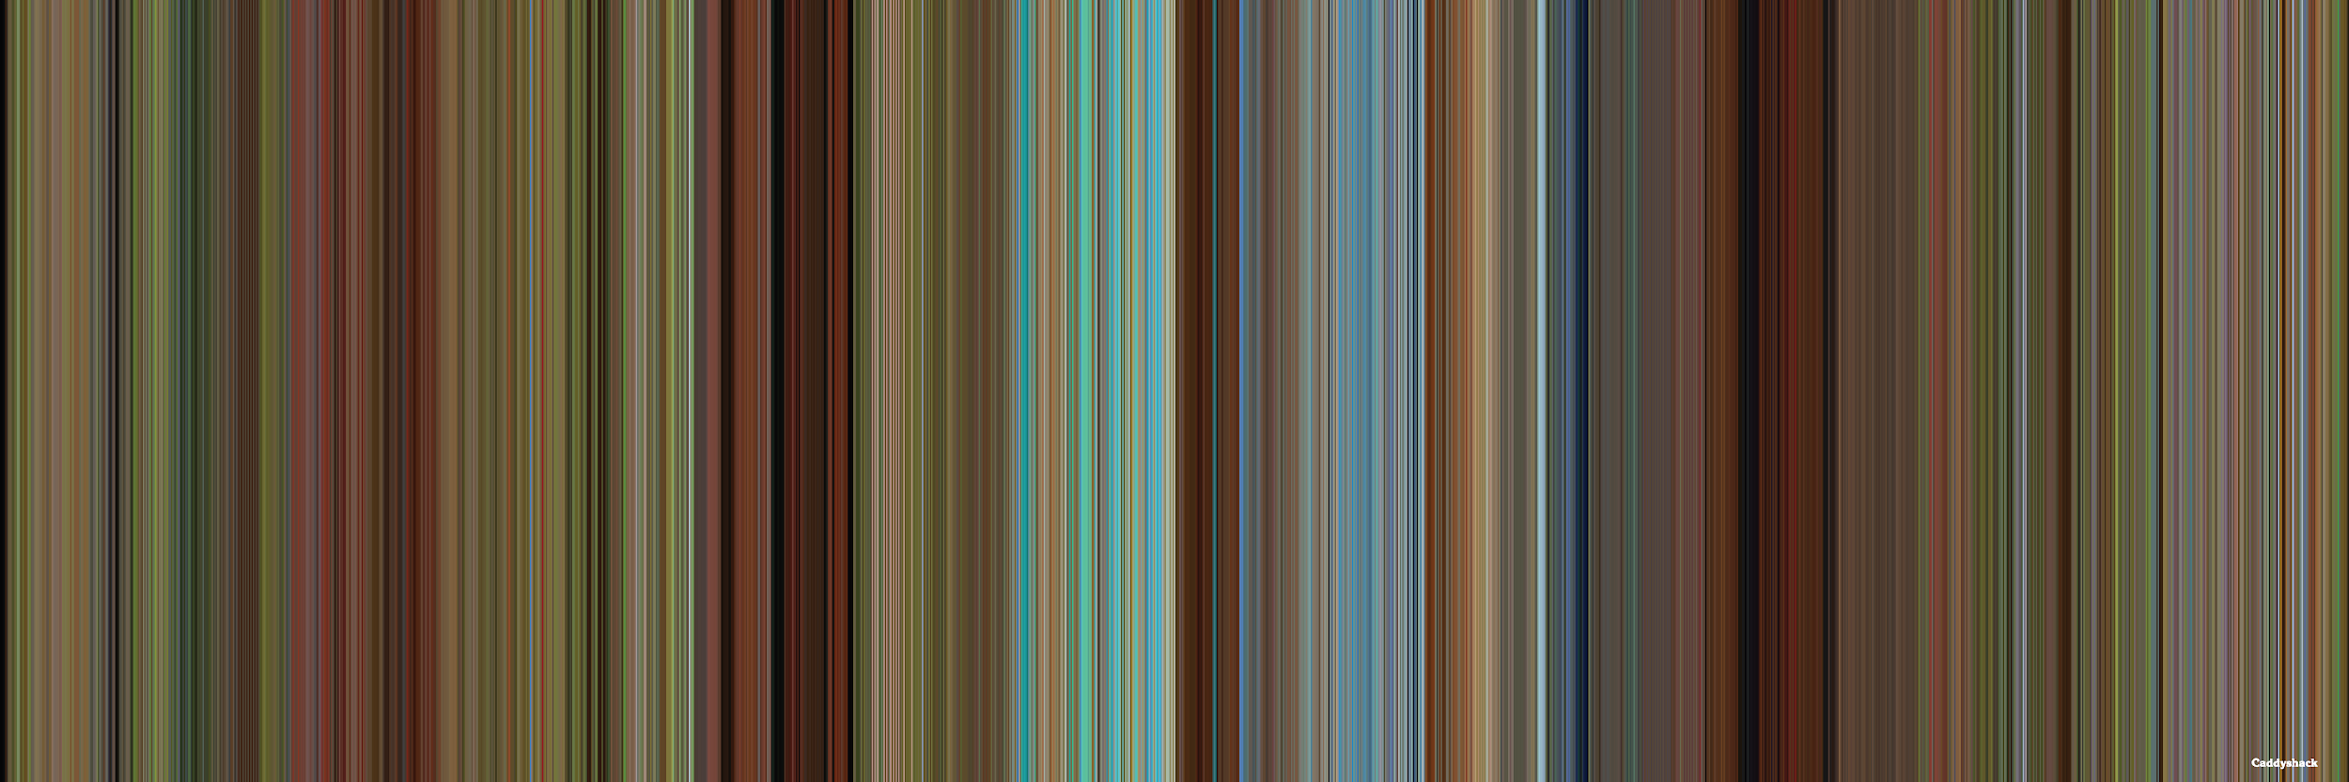

Looking for a unique gift for the movie-lover in your life? Turn their favorite film into an abstract work of art. Each colored line represents a scene from the film and the dominant color in that scene. Combine all the scenes and colors into something truly unique. Finished products will measure 12”x36” and can be printed on paper or panel with a frame. One month's notice is requested for time to create the art, ordering, and framing.